MARMARA UNIVERSITY
FACULTY OF ENGINEERING
COMPUTER ENGINEERING

PHYS1103
PHYSICS LABORATORY
EXPERIMENT 5
Straight Line Motion with Constant Velocity
SXGXE5

NAME | STUDENT NUMBER

Submitted to: Hüseyin YALTIRIK

Experiment Date: 19.11.2019 Due Date: 26.11.2019
1-) PURPOSE
In this experiment we will look to Atwood’s machine on an air table to examine Newton’s second law.
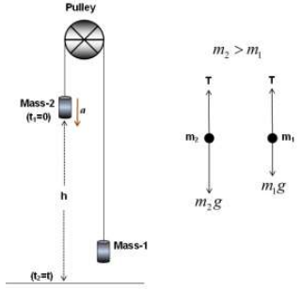
2-) THEORY
These figures are Atwood’s machine and its free body diagram of forces.
Atwood’s machine is a system for find out the acceleration of an object, examine the relationship of acceleration and force in a system. For moving a motionless object first there must to be a force applied on object. The acceleration of the object is related to net force applied on the object.
In Atwood’s machine there is two different masses called $m_{1} and m_{2}$ (the mass of $m_{2}$ is more than $m_{1}$) bonded to a rope that passing over a pulley. When we leave the masses from the top because of the $m_{2}$ is heavier than $m_{1}$, $m_{2}$ will moves downward with constant acceleration. And $m_{1}$ will moves with same acceleration upward. $m_{2}g$ is bigger than T because $m_{2}$ moves downward and $m_{1}$g is smaller than T because $m_{1}$ moves upward.
Units in Newton’s Second Law
Force | Mass | Acceleration
Newton(N) | Kilogram(kg) | m/$s^{2}$

The unit of force is Newton(N). Since $F=m⋅a$, Newton is only related to mass length and time (1N=1kg/ m/$s^{2}$).
In this experiment $m_{2}$ is the heavier object. T is the tension in the string. The net forces on the objects are: $m_{2}$ – T for the $m_{2}$ object and T- $m_{1}$ for the $m_{1}$ object. As we knew from Newton’s Second Law the acceleration is on the same way with net force. We can write the equation like:
$$\vec{a}= \frac{\sum{\vec{F}}}{m}$$
Since the net force is not zero there is an acceleration on the objects. For both objects the net force is equal to multiplication of mass and acceleration of the object:
$$\sum{\vec{F}}=m\vec{a}$$
From Newton’s Second Law we can understand these equations:
$$F_{net}=T-m_{1}g=m_{1}a$$
$$F_{net}=T-m_{2}g=m_{2}a$$
The gravity force on an object (mg) called the objects weight.
In Atwood’s machine weights of this objects determines the net force on the system. It determines the magnitude and way of net force. In our example $m_{2}$ is have more weight then $m_{1}$ and this determines system will go downward for $m_{2}$ and upward for $m_{1}$.
If we modify the equalizations above, we get:
$$T= m_{1}a+ m_{1}g$$
$$T= m_{2}g- m_{2}a$$
$$m_{1}a+ m_{1}g= m_{2}g- m_{2}a$$
$$m_{1}a+ m_{2}a= m_{2}g- m_{1}g$$
$$a=g(\frac{m_{2}- m_{1}}{m_{1 + }m_{2}})$$
The last equation gives us expected (theoretical) acceleration for both objects. In Atwood’s machines the net force equals to difference between two objects times gravitational acceleration
If $m_{2}$ object released from a h height in a t time with $t_{1}$= 0 initial velocity until the time that it will hit the ground and this time is $t_{2}$=t. The formula for this system for distance of object to the ground is y and linear acceleration is a:
$$y=y_{0}+v_{0}t+\frac{1}{2}at^{2}$$
We know the initial velocity and initial position zero, so the equation becomes:
$$y=\frac{1}{2}at^{2}$$
If we have the information of a, we can find the y distance in a time interval.
In Atwood’s machine we know the initial velocity and the initial position is zero so we will use this equation. We can modify this formula for a:
$$a=\frac{2y}{t^{2}}$$
y-t graph with constant acceleration is always will be a graph that passes through origin. If we plotted a y-$t^{2}$ graph we will a straight line that has a slope of:
$$slope=\frac{1}{2}a$$
This formula will give us the acceleration on the Atwood’s machine.
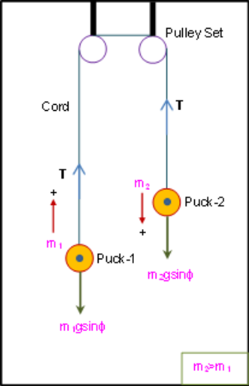
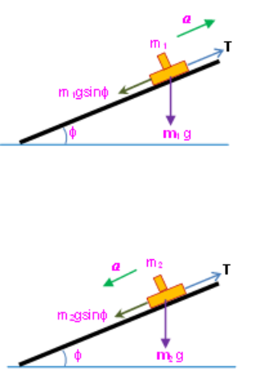
The experiment based on the heavier puck will moves downward and that will bring a move for the system. The system of Atwood’s machine is two pucks connected with a string which passes over two pulleys on an air table with an angle of Φ
The mission of two objects are being a mass. Putting extra mass on objects increases the mas of pucks. The heavier object is $m_{2}$.The forces on the air table are:
- T (tension) forces to object upward
- $m_{2}gsinΦ$ as the component of its weight
The object accelerates downward, we can understand from here the weight is bigger than the tension. The equation is:
$$m_{2}gsinb-T=m_{2}a$$

The equation of net force on is:
$$T-m_{1}gsinb=m_{1}a$$
If we add these two equations, we will get:
$$a=(\frac{m_{2}- m_{1}}{m_{1 + }m_{2}})gsinΦ$$
The acceleration related to gravitational acceleration.
For the tension we can use the formula of:
$$T=\frac{2{m_{1}m}_{2}}{m_{1}+m_{2}}gsinΦ$$

3-) EXPERIMENTAL SETUP
- 2 pucks
- Air table
- 2 weights
- 2 pulley set
- A string
In Atwood’s machine the system is like in the figure, but it is on a inclined table. We are release both objects and examine the system. We knew the distances taken from the rest and the time has passed. We are using this formula to find the acceleration:
$$y=y_{0}+v_{0}t+\frac{1}{2}at^{2}$$
But since we know $y_{0} and v_{0}$ are equal the zero, this formula becomes:
$$y=\frac{1}{2}at^{2}$$
If we modify this formula for making easier to our job for finding the acceleration the formula becomes:
$$a=\frac{2y}{t^{2}}$$
But we are making our experiment on an inclined table like this and there is another thing which effects the system and our examination. It is the inclination angle. Now we know the acceleration. For finding the slope of inclined plane there is simple thing:
$$slope=\frac{1}{2}a$$
After we found these experimental stuffs now, we are looking for expected values of the acceleration and tension in the string with these two formulas:
$$a=(\frac{m_{2}- m_{1}}{m_{1 + }m_{2}})gsinΦ$$
$$T=\frac{2{m_{1}m}_{2}}{m_{1}+m_{2}}gsinΦ$$
4-) CALCULATIONS & RESULTS
Table 1 Position and time measurements of five data points of the pucks m₁ and m₂ for the Atwood’s system
Dot Number | Measured |  |  |  | Experimental
Dot Number | Position |  | Time | Square of time | Slope
Dot Number | Mass, m₂ | Mass, m₁ | Time | Square of time | Slope
Dot Number | y(m) | y(m) | t(sec) | t²(s²) | s(m/s²)
0 | 0 | 0 | 0 | 0 | 0.256
1 | 0.005 | 0.005 | 0.10 | 0.01 | 0.256
2 | 0.015 | 0.014 | 0.20 | 0.04 | 0.256
3 | 0.027 | 0.027 | 0.30 | 0.09 | 0.256
4 | 0.044 | 0.043 | 0.40 | 0.16 | 0.256
5 | 0.064 | 0.063 | 0.50 | 0.25 | 0.256

Table 2 Experimental data values
Angle of inclination, b(deg): | 9
Spark-timer frequency, f(Hz); | 10
Puck, $m_{1}$ (kg): | 0.575
Puck with extra mass, $m_{2}$ (kg): | 0.860
Slope, s(m/$s^{2}$): | 0.256
Acceleration, a(m/$s^{2}$): | 0.512
Acceleration due to gravity, g(m/$s^{2}$): | 16.48
Tension in the cord, T(N): | 1.78
Weight of the puck with extra mass, W(N): | 12.48

Table 3 The values of the acceleration (Experimental, Expected and Calculated)
Acceleration due  to gravity  (Experimental) | Acceleration due  to gravity  (Expected) | Acceleration due  to gravity  (Calculated)
g(m/$s^{2}$) | $g^{'}=$ (m/$s^{2}$) | $$g±\%$$
16.48 | 9.81 | 68%

Graph 1 Position-time graph of $m_{2}$
Graph 2 Position-time graph of $m_{1}$

5-) CONCLUSION & DISCUSSION
- Atwood’s machine basically a set-up with two objects for examine the movement of objects and find their acceleration and the net force upon them. The net force on the system causes because of the weights differences of the objects.
- From this formula:
$$y=y_{0}+v_{0}t+\frac{1}{2}at^{2}$$
If we know the information of $y_{0}$(initial position) and $v_{0}$(initial velocity) then we can find the acceleration from the distance and time measurements.
- There are two different weights in different ways on an inclined plane, we assume the angle between plane and ground is equal to b. The bigger one will determine the net force; we can show the equation like:
$$F_{net}=m_{2}gsinΦ-m_{1}gsinΦ$$
We also know Newton’s second law; from this formula we know the net force is equal to multiplication of total mass and the acceleration of the system. For this figure it will be:
$$m_{2}gsinΦ-m_{1}gsinΦ={(m}_{1}+m_{2)}a$$
If we modify this formula for acceleration it will become:
$$a=(\frac{m_{2}- m_{1}}{m_{1 + }m_{2}})gsinb$$
- From the Newton’s second law if the net force is constant the multiplication of total mass and the acceleration of the system will always be equal to magnitude of this constant net force.
$$\sum{\vec{F}}=m\vec{a}$$
- $a=\left(\frac{m_{2}- m_{1}}{m_{1 + }m_{2}}\right)gsinΦ$
If we examine that formula the value of ($m_{2}- m_{1})$ is constant but the value of ($m_{1 + }m_{2}$) is increases, so the acceleration will decrease with time.
- Since both objects connected the same string they will move together. They displacements, velocities and accelerations will be in the same magnitude.
- Like we have discussed above the magnitude of acceleration is same for both objects, but since the acceleration vectoral, we need to look to directions of these accelerations. The heaviest object moves downward, and the lighter object moves upward. They accelerated in different ways so they acceleration are not same.
- In this experiment we have examine for somethings. We have seen the Atwood’s machine. What we have learned are it is very relevant to Newton’s second law. Atwood’s machine is a structure by using two objects connected by a rope which is passing over two pulleys. In the experiment which we did there was a heaviest object. And this weight difference caused a net force and it starts the movement. If the weights of these two objects are the same, because of there won’t be a net force there won’t be a movement either. We have weight difference and according to Newton’s second law since these two objects weights are pulling the system in different ways, the net force will be equal to weight difference. The system will moving downward to heavier object. If we know the distance and time we can find the acceleration From the Newton’s second law. Since we know the masses of these objects and the acceleration we can find the tension in the rope. Everything in Atwood’s machine can be found with Newton’s second law.
6-) APPENDIX
